Determining Normality
Pulse

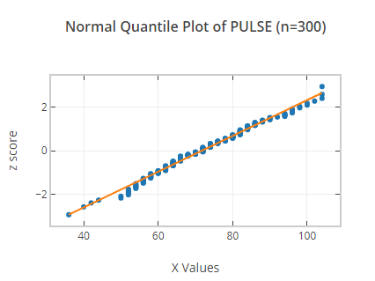
From the analysis above shows that pulse is not normally distributed. The histogram shows that the data is not unimodal since it has 3 modes. The Q-Q plot shows the data does not lie on a straight line making it to be not normally distributed.

HDL
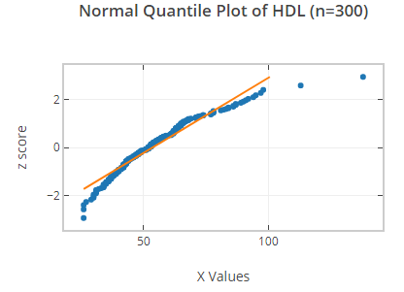

The data is not normally distributed since the Q-Q plot shows that the points are not on as straight line. The histogram also shows that the data has a longer tail on the right hence its positively skewed.

RED
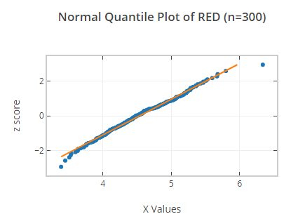

The red blood cells data is normally distributed since Q-Q plot shows that the data lies on a straight line. The histogram is relatively bell shaped meaning that its normally distributed.

